



Essay / Assignment Title : Developing an End-to-End Big Data Pipeline Using Hadoop, Spark, Hive, and Mllib

Programme title : Big Data Analytics

Name : Yusufu Ahmara Savage

Year : 2024 / 2025

CONTENTS

Contents
CONTENTS 2
INTRODUCTION 4
1. Problem Definition and Business Context 5
1.1. Defining Big Data and its Business Value 5
1.2. Challenges 5
1.2.1. The Three Vs: 5
1.2.2. Ethical Considerations: 5
1.3. Case Study – Industry/Domain 6
1.4. Technologies (Platforms and Tools) 7
2. Environment Setup and Data Storage 8
2.1. Introduction 8
2.2. Containerized Applications Used 9
2.3. System Architecture 9
2.4. Hadoop System Architecture 11
2.5. Hive Logical Framework – Schema Definition 12
2.6. Hive Schema Definition and Creation 13
2.6.1. HDFS Configuration 13
2.6.2. Dataset Upload in Hive 15
2.7. PySpark Schema Definition and Creation 16
2.7.1. HDFS Configuration 16
2.7.2. Dataset Upload in Hive 16
3. Data Processing with Spark and Hive 18
3.1. Data Wrangling and Transformations Using Spark 18
3.2. Data Wrangling and Transformations Using Spark 18
3.3. Comparing performance, expressiveness 20
4. Advanced Analytics and Machine Learning 21
4.1. Data Wrangling and Transformations Using Spark 21
5. Reflection and Recommendations 23
6. BIBLIOGRAPHY 24
7. APPENDIX 25
7.1. Project Repository 25
7.2. Project Repository 25
7.3. Link to Case Study Data Set 25

Statement of compliance with academic ethics and the avoidance of plagiarism

I honestly declare that this dissertation is entirely my own work and none of its part has been copied from printed or electronic sources, translated from foreign sources and reproduced from essays of other researchers or students. Wherever I have been based on ideas or other people texts I clearly declare it through the good use of references following academic ethics.
(In the case that is proved that part of the essay does not constitute an original work, but a copy of an already published essay or from another source, the student will be expelled permanently from the postgraduate program).

Name and Surname (Capital letters):

YUSUFU AHMARA SAVAGE

Date: 31/05/25

INTRODUCTION

This documents detailed responses to questions provided on the final assessment paper for this module, and it is based on the application of Big Data Analytics concept through implementing an end-to-end pipeline using Docker, with Hadoop, Apache Spark and Hive images.
The project is hosted on GitHub, and the link is provided in the Annex.

Problem Definition and Business Context

Defining Big Data and its Business Value
Big Data refers to extremely large and complex datasets that traditional data processing tools cannot efficiently handle. These datasets are characterized by the three Vs; Volume, Velocity and Variety, however, the values Big Data offer Businesses include informed decision-making, personalized customer experience, operational efficiency, competitive advantages and risk mitigation.

Challenges
The following explains and detail challenges associated with Big Data Analytics.

The Three Vs:
  - Volume: This is the massive amounts of data being populated from different sources. It is significantly difficult to store and manage data in petabytes.
  - Velocity: The data is being generated at a high speed and further processed accordingly. Therefore, makes it difficult in integrating Structured, Semi-Structured and Unstructured data.
  - Variety: The variation of types of data is explained below. And these variations posed difficulties in the processing of data in Real-time, or close to Real-time.
  - Structured Data: these are well organized data in a predefined tabular form with rows and columns, such as relational databases e.g. SQL Databases, Spreadsheet etc. They are easy to store, query and analyse using traditional tools.
  - Semi-Structure Data: These data do not reside in a relational database, but still has some organizational properties e.g. JSON, XML YAML files etc. NoSQL Database (e.g. MongoDB) Emails (with headers, body etc.), However, they are more flexible and can be passed and analysed with a little more effort when compared to that of a Structured Data.
  - Unstructured Data: These are data that do not have a predefine format or structure, which makes it more complex to process and analyse e.g. images, videos and audios files, and social media posts. These types of data provide rich information and insights. However, requires advance tools to extract values.

Ethical Considerations:
  - Data privacy: Big Data often involves collecting personal or sensitive information (e.g., health records, location data, online behaviours). The concern is, individuals may not be aware of how their data is collected, used, or shared; therefore, it is better to implement strong data anonymization, obtain informed consent, and comply with regulations like General Data Protection Regulation – GDPR or Health Insurance Portability and Accountability Act – HIPAA.
  - Data Security: Since large datasets are attractive targets for cyberattacks, therefore the concern is, breaches can expose personal data, leading to identity thief or financial loss. As a result, a robust encryption, access controls, and regular audits need to be implemented to protect data.
  - Bias and Fairness: Algorithms trained on biased data can reinforce or amplify discrimination, which can lead to unfair outcomes in areas like hiring, lending, or law enforcement. Therefore, datasets and models need to be audited for bias and ensure diverse data representation.
  - Transparency and Accountability: Big Data Systems and AI models can be opaque (“black boxes”), and it is of concern that users and stakeholders may not understand how decisions are made, therefore, explanations for automated decisions and maintaining clear documentation of data sources and model logic are necessary.
  - Ownership and Consent: It is often not clear who owns the data and how it can be used, and data may be used in ways that individuals did not agree to, therefore, clear data governance policies and respect user rights need to be established.
  - Ethical Use of Predictive Analytics: Predictive models can influence behavior or decisions (e.g., predicting crime or health risks), if misuse can lead to profiling, surveillance, or denial of services. Therefore, predictive tools must be used responsibly, with human oversight and ethical review.

Case Study – Industry/Domain
This exercise uses data from the healthcare domain, and cited Use Case from the Radiological Society of North America (RSNA) Radiology Informatics Committee (RIC) Pediatric Bone Age Machine Learning Challenge Organizing Committee, to deal with challenge in creating a model that solve problem in correctly identifying the age of a child from an X-ray of their hands.

Determining a child's Bone Age (biological maturity) from a hand X-ray is traditionally done manually by comparing the image to reference atlases referenced ​​(Bell & Jones, 2020)​. This process has been time-consuming, subjective to and depends on the radiologist’s experience and prone to human error.

Using steps listed below, Big Data Analytics can adequately address these challenges in determining Bone Age through the following:
- Data Collection: Gather thousands of labelled hand X-ray images from diverse populations and age groups. Include metadata such as chronological age, gender, and ethnicity.
- Data Processing: Use image preprocessing techniques to normalize and enhance X-ray images and annotate key features (e.g., growth plates, bone shapes).
- Machine Learning & Deep Learning: Train Convolutional Neural Networks (CNNs) on the X-ray dataset to learn patterns associated with different ages. Use models like ResNet, VGG, or EfficientNet for high accuracy.
- Prediction: The trained model can predict the bone age of a new X-ray image within seconds, and accuracy improves with more data and diverse training samples.
Furthermore, the benefit is maximized by the following:
- Speed: Providing instant Predication
- Consistency: Reduces variability between Radiologist.
- Scalability: Can be deployed in remote and areas with limited resources.

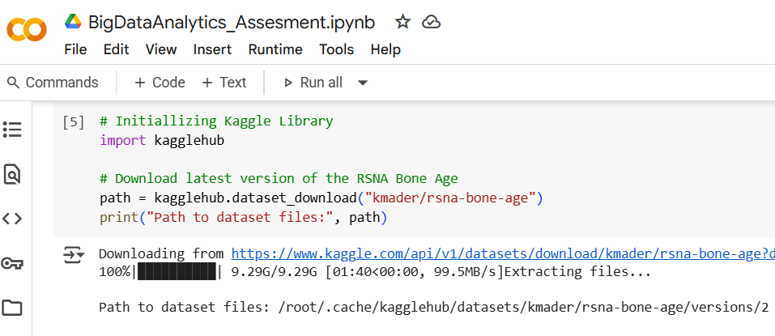
The data and images combined in this Use Case are up to 9.29GB, and due to challenges fetching the Data from Kaggle repository, because of limited local resources (Hard Drive Space), the following tools were used:
Figure 1.1

- Google Collaboration Tool through Jupyter Notebook – (Python 3 Kernel): It supports the use of Jupyter Notebook with Python and provides access to wide range of libraries that support advance analytical tasks.

- Google-Drive – Cloud Platform (API Version 3): A Cloud storage facility provided by google for easy and real-time access to personal data. The Desktop version of Google Drive was used to easily synchronize the files to local PC, preparing for the analysis.
Note: That the task can also be achieved locally in Docker, using JupyterLab.

Figure 1.1: Shows how the data was downloaded from Kaggle Repository.
Figure 1.2: Displayed command that shows downloaded folder and contents. And
Figure 1.3: Shows Google Drive Workspace.

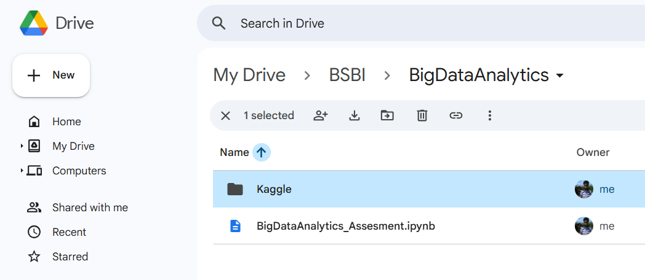
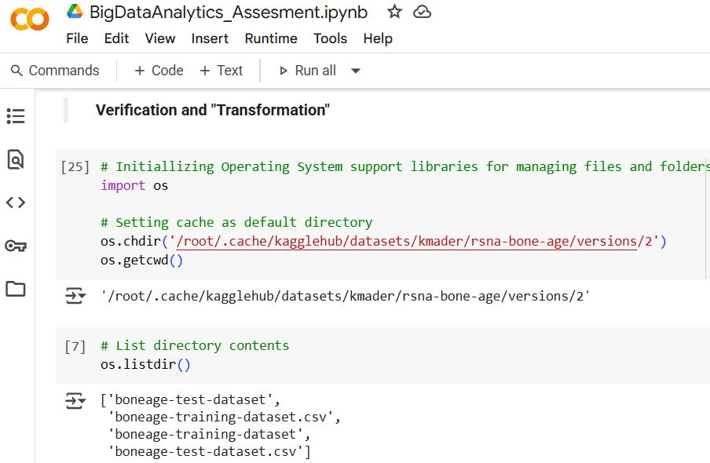
Figure 1.2
Figure 1.3

Data fetched from Kaggle has already been split into Testing and Training with additional two folders containing images for both the Testing and Training CSV files, see Figure 1.2. However, it was understood that the Test Dataset does not have data (empty) and therefore, was dropped/ignored.
Consequently, the Training Dataset and images specific to the data are used as the foundation for analysis and model predication in this project.

Technologies (Platforms and Tools)
The following is a list of services, tools and platform used in the implementation of this project. However, a comprehensive list and explanation on how the technologies will support the project is provided in the next section.
- Docker Container
- Apache Hadoop Framework
- Apache Spark
- Apache Hive
- JupyterLab

Others:
- Windows PowerShell – Integrated Scripting Environment ISE
- Visual Studio Code – IDE

Environment Setup and Data Storage

Introduction
The project shall be called Hadoop-Hive-PySpark-Docker, derived from the selection of project tools from the Assignment Brief, an architecture considered suitable for analyzing the use case: Bone-Age. The project started with the installation of Docker using Windows Graphical interface, followed by creating and setting up GitHub Repository. The rest of the services and tools were deployed using sequence in bullet point below:
- Git Bash: is used for the installation of a few dependencies that are required for Docker to run, and
- Use Docker Interface to install updates and ensure it is running the latest version.
- PowerShell ISE: is used to clone GitHub Repository into project folder and perform advance troubleshooting during the installation of container images, making use of the code management interface provided, and alternatively used to start and stop containers running within docker.
- Microsoft Visual Studio: is used to create files and folder structure, and further pushed data to Git Repository, providing a rich interface for editing codes and facilitating Versioning Control through Git.
- Docker: also provides command line tool which is an alternative that was used arbitrarily to achieved some of the tasks that were done using tools mentioned above.

The following structure is used to ensure images are successfully deployed in docker containers. The configuration files were created using VS Code and the below briefly explains the purpose of each file in the setup structure.

Docker Setup File Structure / Hadoop, Hive, Spark
- |-- docker-compose.yml – The configuration file used to deploy images in Docker.
- |-- dockerfile – The file that automates the creation of Docker images as it contains codes and links to libraries, dependencies, environmental variables and system tools.
- |-- hive/hive-site.xml – This file defines key configuration properties and Runtime Behaviour for Hive services such as Database Connections, Execution Engine settings, and Optimization rules.
- |-- spark/spark-defaults.conf – This file sets default values for Spark configuration properties, which includes memory allocation, number of executor cores, logging levels, or application parameters.
- |-- scripts/init-hive.sh – This is a Custom Shell Script, written o initializes Apache Hive during the automated deployments, Docker containers, or Hadoop clusters
- |-- notebooks/example.ipynb – This is a Python Notebook file pre-coded to connect to Hive and shows databases.
- |-- data/boneage-dataset.csv – This is the Case Study CSV file uploaded in the data directory.
- |-- data/boneage-image – This is a folder containing the x-ray of the left hand of children in the Case Study. Note: that this is being from GitHub through. gitignore because it is 9.14GB large.
- |-- assets/architecture.png – Platform diagram shows layers relations and flow of activities.
- |-- README.md – This file provides information regarding the project.
- |--. gitignore – Was added to prevent specific content from being uploaded to repository.

The illustration below (Fig. 2.1) shows folder structure within Visual Studio Code with the YAML configuration files showing codes used for the creation of the first two containers within the project.

Figure 2.1: Visual Studio Code Showing the; Yet Another Markup Language - YAML Configuration File
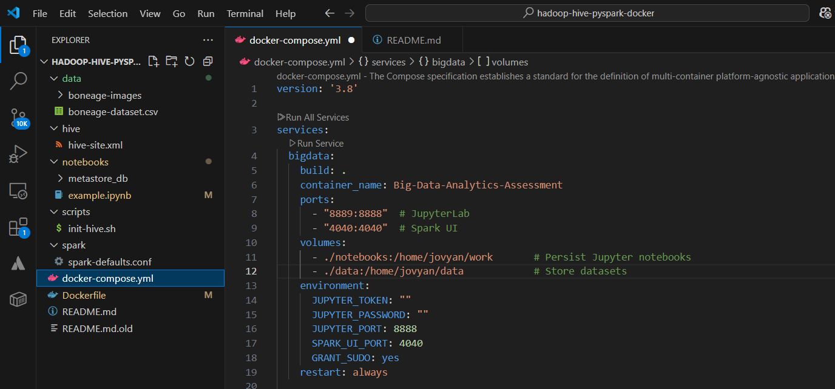

Containerized Applications Used
The below (Table 2.1) provides a comprehensive list of applications, their versions, categories of app. (being a tool or an underlying process) and how they relate to Docker and Hadoop.
Table 2.1: List of Applications Used in Project.
Application | Version | Category | Sub App Of. | Role / Relations in Project
Docker Container | 4.41.2 | Platform |  | Creates containers from images.
Apache Hadoop Framework | 3.4.1 | Platform |  | Distributed storage and processing
Name-Node / HDFS | 28.1.1 | Service | Hadoop Framework | Docker Image /with Hadoop
Data-Node / HDSF | 28.1.1 | Service | Hadoop Framework | Docker Image /with Hadoop
Apache Hive | 28.1.1 | Tool |  | Docker Image /with Hadoop
Apache Spark | 28.1.1 | Tool |  | Docker Image /with Hadoop
JupyterLab | 4.0 | Tool |  | Docker Image /Interact with Spark & Hive
Git Bash | 2.49.0 | Tool |  | External /Docker & Subsidiary App Deploy/Interact
Windows Power Shell ISE | 5.1.26100.4202 | Tool |  | External /Docker & Subsidiary App Deploy/Interact
Microsoft Visual Studio Code | 1.1003.1 | Tool |  | External / Coding & Versioning

System Architecture
The following provides explanation on how these technologies supports this project:
- Docker: Provides a containerized platform that enables the creation, deployment, and running of applications in containers. It is a lightweight, standalone, executable package that includes everything needed to run a piece of software — including the code, runtime, libraries, and dependencies. Furthermore, it resuscitates the host operating system kernel, making it much more efficient than traditional virtual machines (VMs). See Fig: 2.2.

Figure 2.2 – Docker Showing Hadoop with Spark, Hive and Nodes Installed.
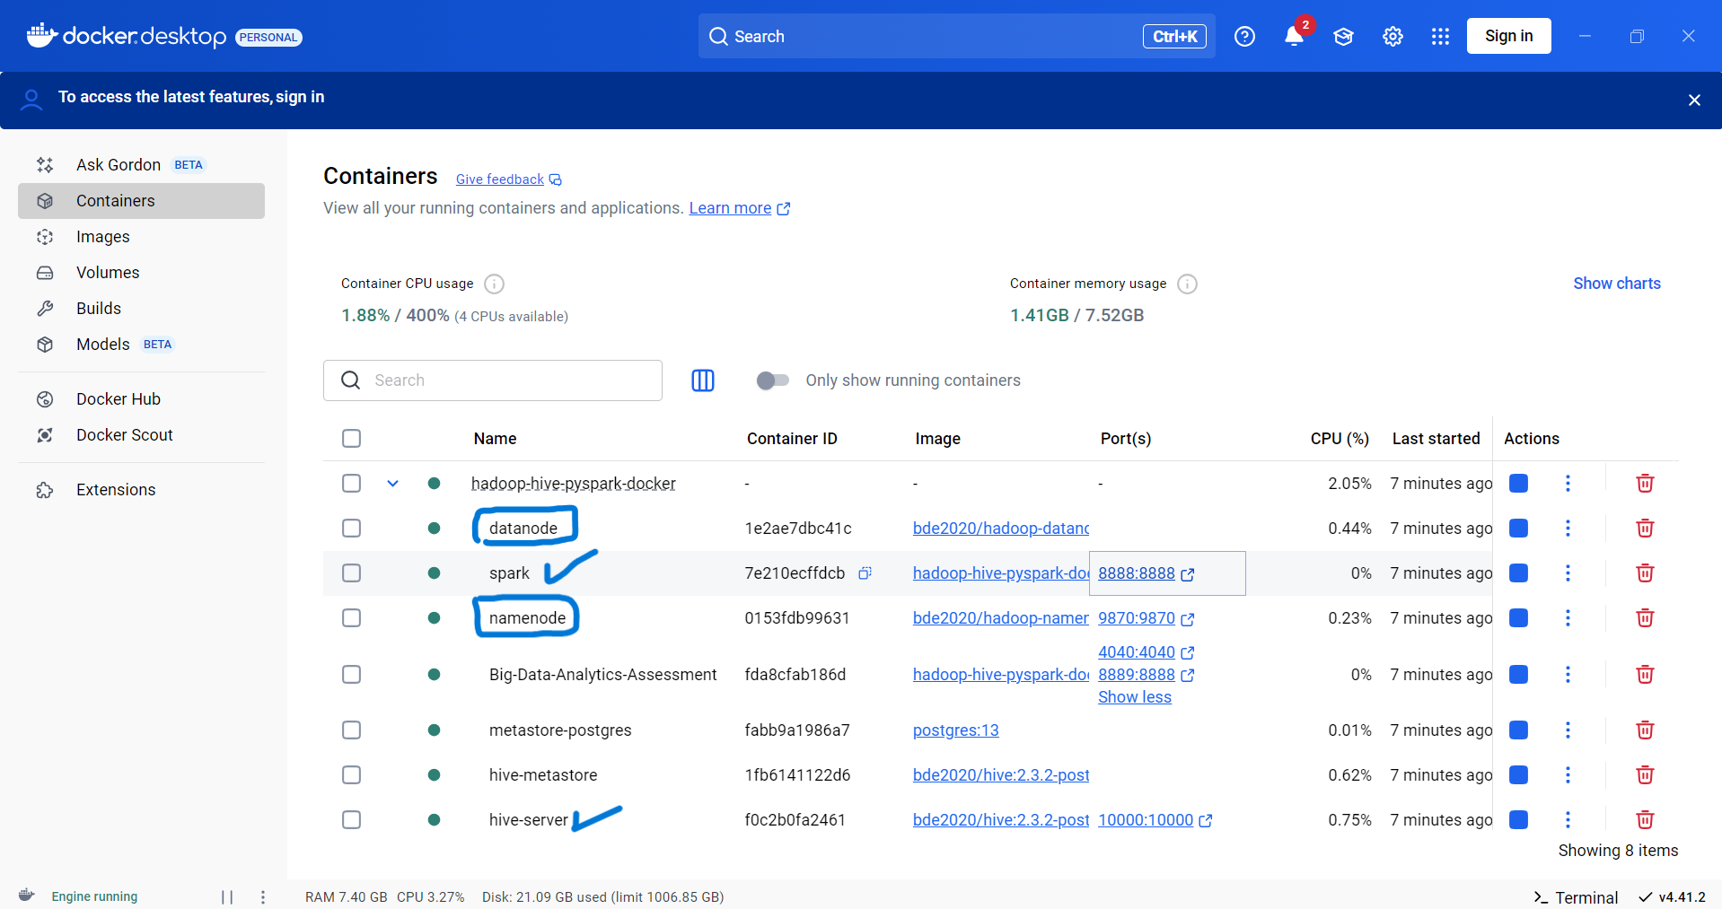

- Hadoop: Is a framework and supports this project by providing the fundamental tools, libraries, and best practices to build and run applications. The following explains Hadoop services components and how they function in the project:

  - Hadoop Distributed File System - HDFS: Is the file system that resides within the storage layer to store large files across multiple machines and provide fault tolerance and high throughputs. It is utilized in the following nodes:
    - Name-Node: Manages the HDFS metadata (file names, directories, permissions and block locations). It's more like the “file system index”, see Fig. 2.3.
    - Data-Node: Also known as “Slave Node” stores the actual data blocks on disk, and is responsible for reading, writing, and replicating data blocks based on instructions from the NameNode.
  - MapReduce: Is used within the processing layer and it is a programming model that support the processing of large-scale of data in parallel, and further break tasks down into smaller sub-tasks across nodes. Since this is a small project, MapReduce is not used, rather was implemented using Deep Learning Frameworks and image preprocessing libraries such as Python with pandas & NumPy that are much better, and suited for this task, since they are optimized for in-memory data processing.
  - The following “Ecosystem Tools” makes Hadoop a comprehensive framework for Big Data Analysis:
    - Yet Another Resource Negotiator – YARN: Is a layered service application that manages resources and perform job scheduling.
    - Hive: Data warehouse system provides SQL like queries on data within Hadoop, stores data in internal database such as Deby, however, Postgres which is an external database is used in this project.
    - HBase: Is a NoSQL column-oriented database on top of HDFS – however, was not used.
    - Spark: Usually used alongside Hadoop recommended due to it fast in-memory processing. And used int this project for distributed and advanced data processing.
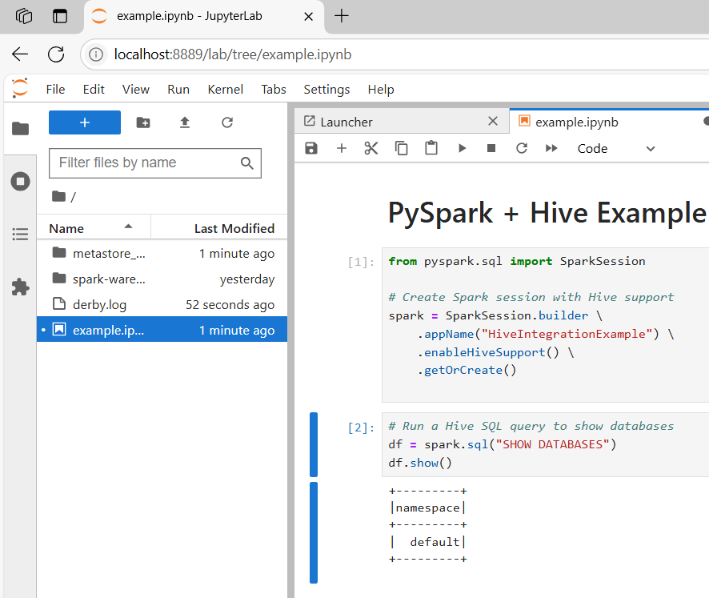
- JupyterLab: Is used to connect to Hive Data Warehouse in a much granular way using Spark, to access and retrieved data from storage using SQL like commends.
Figure 2.2

Hadoop System Architecture
The bellow provides a structured architectural layer used by the project, followed by graphical representation of the data flow, how the platform will store and process data, and at which level user will interact and automate data Retrieval/Extraction, Transformation, Loading, and further perform high level analytical processing.
Note: that an additional tool called Debug Interface Access – DIA (version 0.97.2) was used to create a diagram visualizing the platform Conceptual Framework presented by the Architectural Layers, and a logical framework of the data architecture showing entities relationships.
Architectural Diagram Layers & Flow
- Integration Layer
  - PySpark connects to Hive via JDBC/Thrift
  - Hive reads data from HDFS
- User Interface Layer
  - Jupyter Notebook / PySpark CLI
  - Beeline / Hive CLI
- Data Flow
  - Arrows show the pipeline:
CSV/Images → HDFS → Hive → PySpark → Output

- Docker Layer
Containers for:
- Hadoop: NameNode, DataNode, YARN, MapReduce
- Hive: Metastore, HiveServer2
- PySpark
- Storage Layer
- HDFS stores CSV files and image data
- Processing Layer
- Hive: SQL querying and metadata
- PySpark: Data transformation and machine learning

Figure 2.3: Hadoop-Hive-PySpark-Docker / Bone-Age Analysis Project
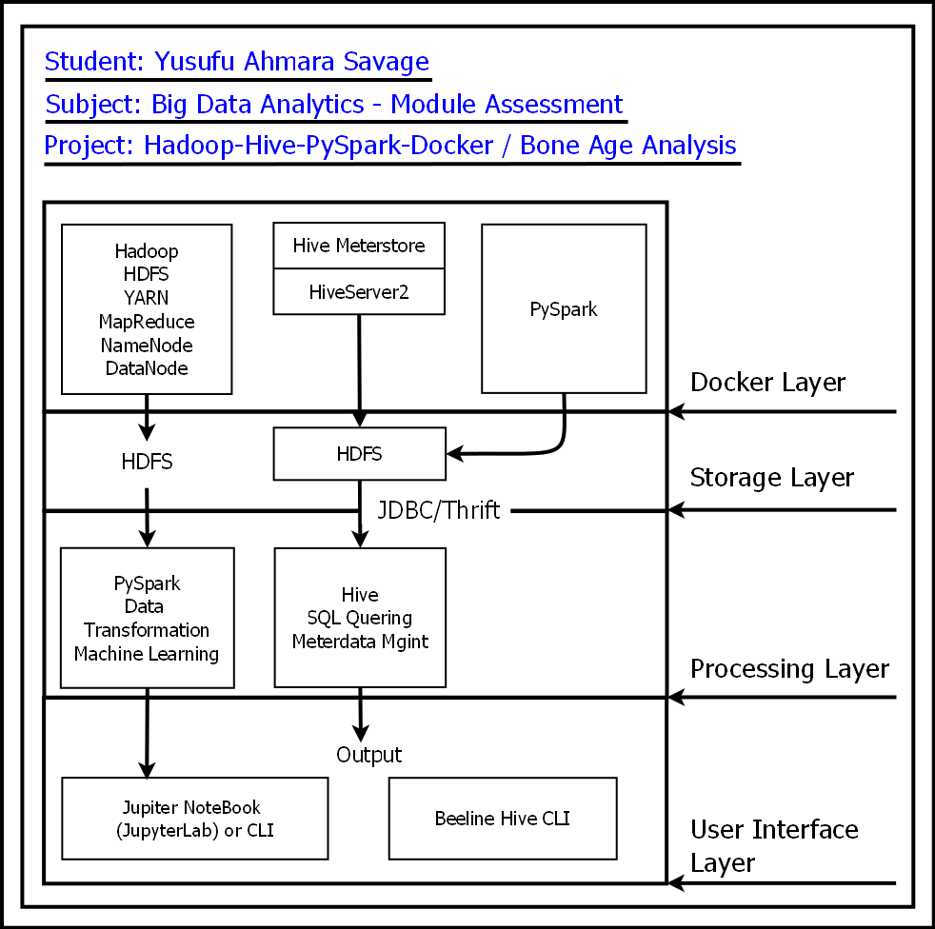

Entity Relationship – ER and Logical Structure of Dataset
The database for this project is called assessment_boneage_analysis and was created with two tables with One – to – One Relationship, since each child can only one scanned image and an image can only belong to a child. See Figure 2.4 below:

- boneage_anal_data: for storing data from Bone-Age CSV file, and
- boneage_anal_images: for storing images metadata (file name & link to directory in hive node).

Figure 2.4: ER & Logical Framework Diagrams
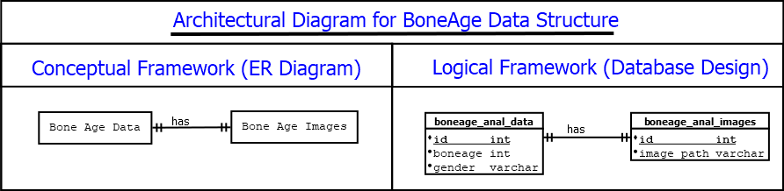

Hive Schema Definition and Creation
The below detailed the schema definition, creation and data operations with screen shots. The following provide more details.

HDFS Configuration
Hive Metastore + Hive Server: configured for querying data on HDFS, and provides the follows:
- Schema Creation: Define tables and schemas using HiveQL.
- Data Retrieval: Query structured data using SQL.
- ETL: Used to transform and load data into structured formats.

The Metastore (PostgreSQL) stores metadata about Hive tables.

PostgreSQL (Metastore DB): Is Backend database for Hive Metastore, and supports the project in the following:
- Schema Management: Stores schema definitions and metadata.
- Data Governance: Ensures consistency and integrity of Hive metadata.

Figure 2.5: Shows Hive Server Configuration.
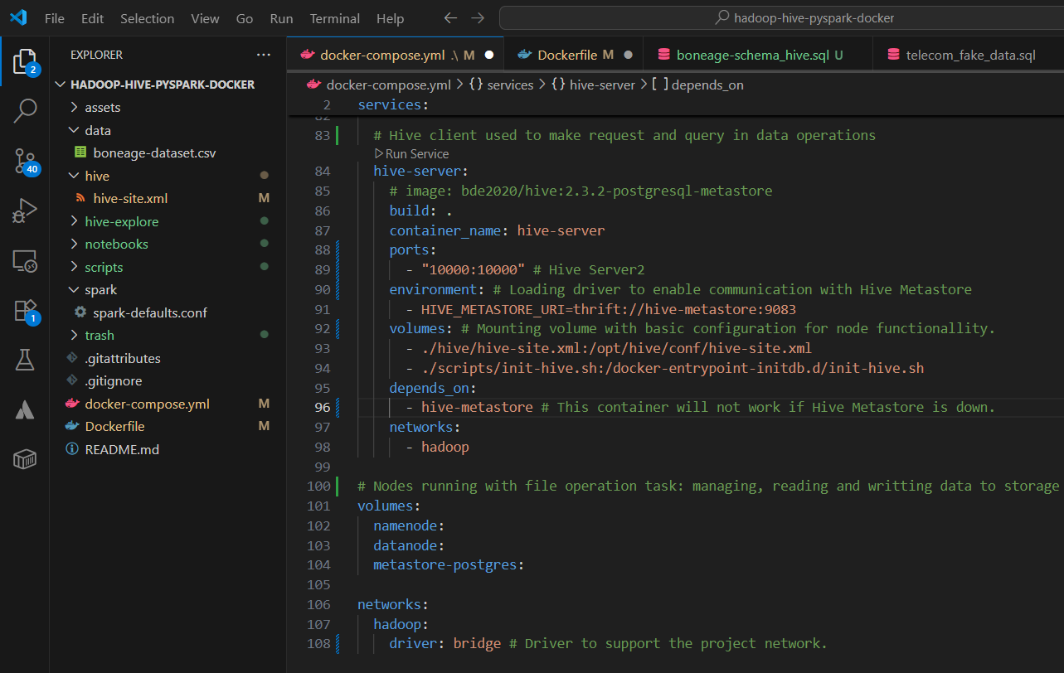

Figure 2.6: Hive Metastore and Metastore Postgres Configuration.
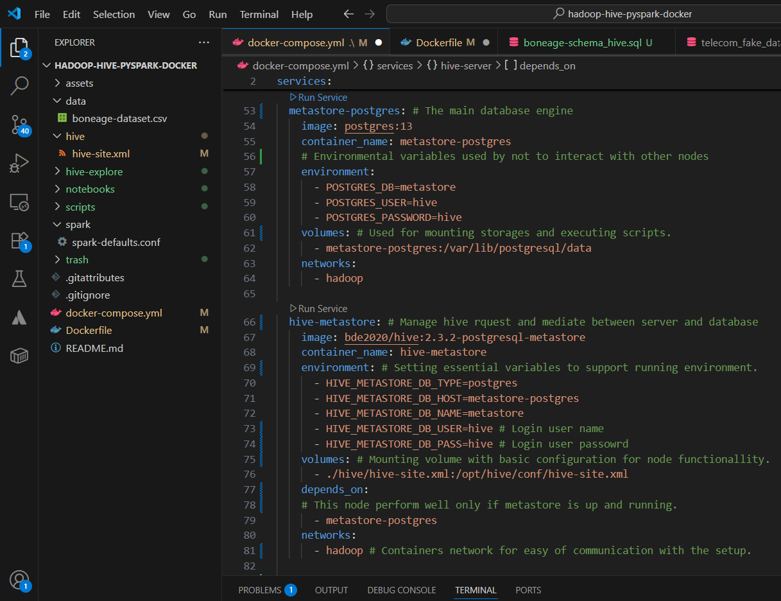

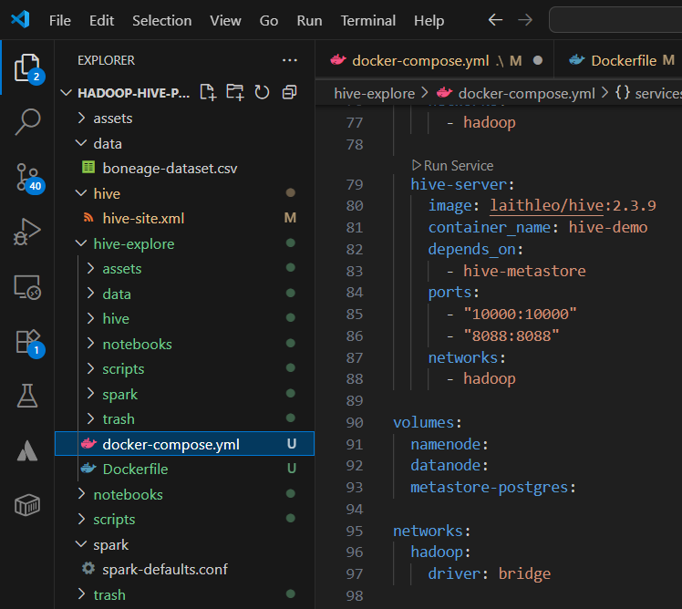
Even though the Hive server within the Hadoop network appears to be properly configured and working, however, could not be logged-on to using beeline CLI. Eventually, the project was switched from using image provided by bde2020 to another one from laithleo that enabled the conclusion of the demonstration. See Figure 2.7.
Figure 2.7

Dataset Upload in Hive
Figure 2.8: Shows data being transfer into Hive Node directory preparing for schema creation and data entry.
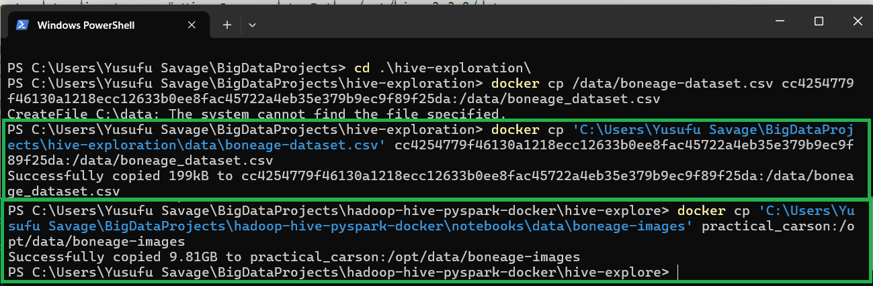

Figure 2.9: Shows Schema and uploaded data, implemented in Hive using Beeline
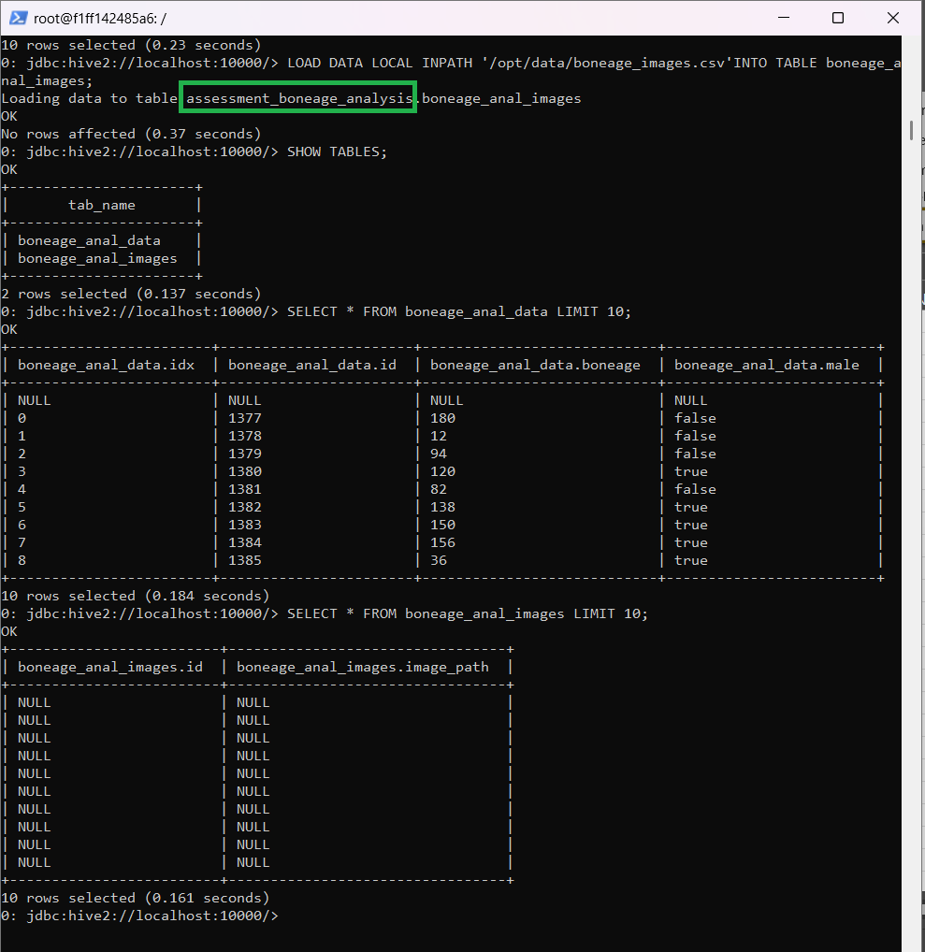

PySpark Schema Definition and Creation

HDFS Configuration
Spark configured with Jupyter Notebook (running Jupyter Lab), to leverage the distributed data processing and advance analytical engine capability when processing data, by applying the following, see Figure 2.9 below:
- ETL: Load data from HDFS/Hive, transform using PySpark.
- Advanced Analytics: Perform machine learning using Mllib and external libraries.
- Image Processing: Load and process image datasets using Spark and Python libraries.
- Interactive Development: Jupyter interface for exploration and visualization.

Figure 2.10: Shows Docker Compose code used in creating PySpark container
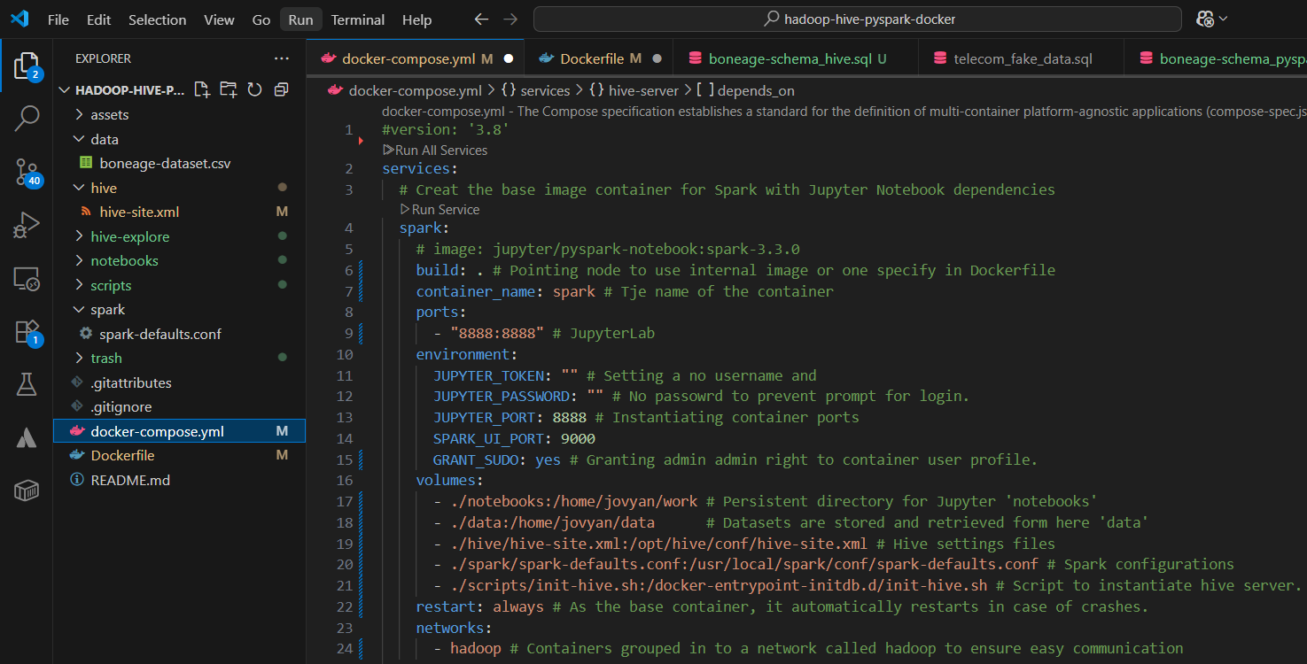

Dataset Upload in Hive
Before creating and uploading data in hive through Spark, Figure: 2.11 shows code used to automate the creation of a metadata CSV file that was used to populate entries in the “boneage_anal_images” metadata table.
Figure 2.11
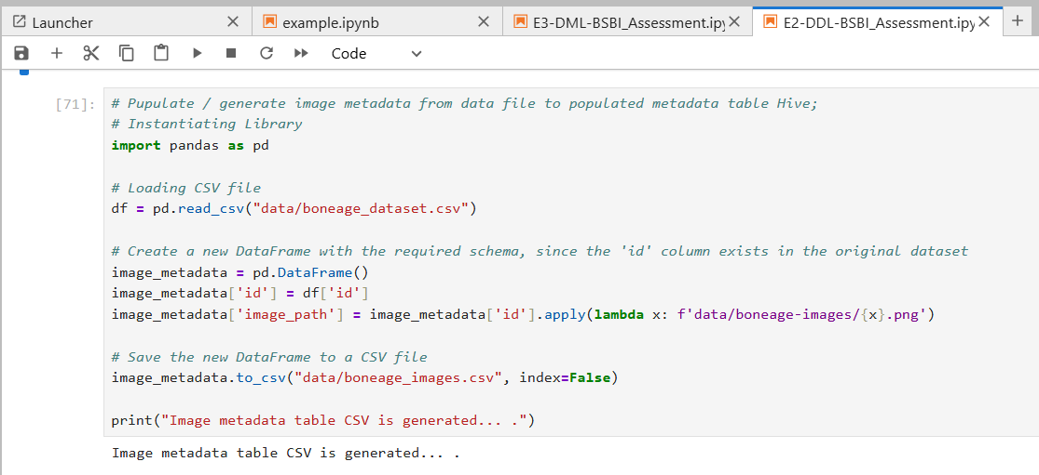

Figure 2.12: Illustrates the creation and loading of data into BoneAge Data table:
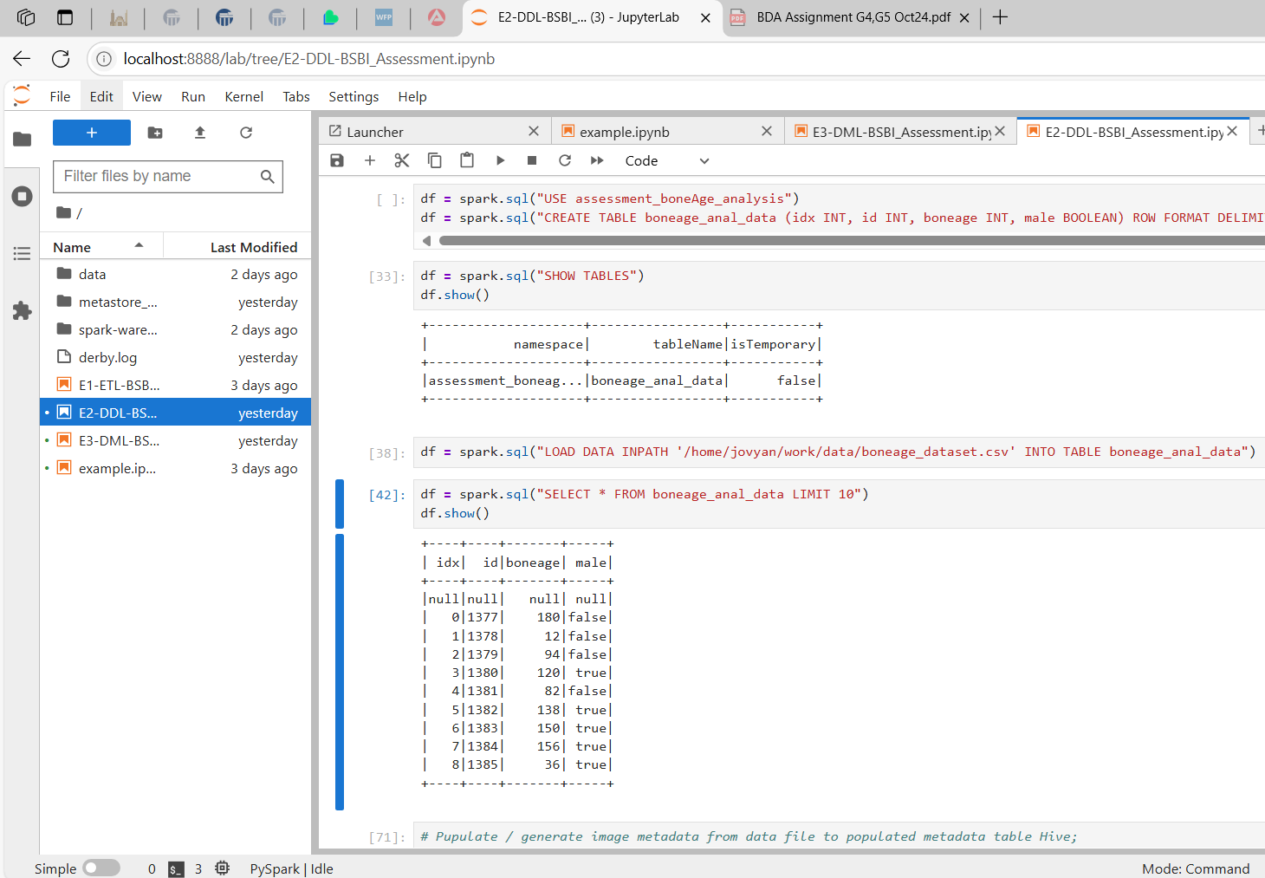
Figure 2.13: Creation and loading of image metadata in table.
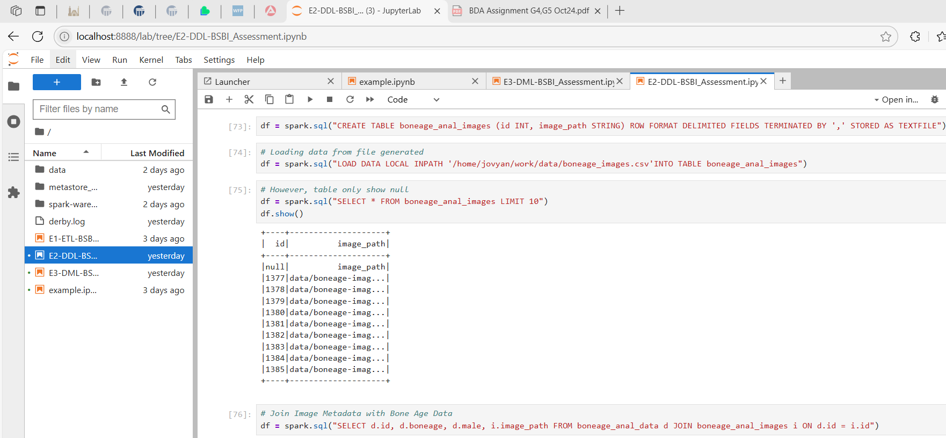

Data Processing with Spark and Hive

Data Wrangling and Transformations Using Spark
Figure 3.1: Show Data Wrangling activities with the boneAge data.
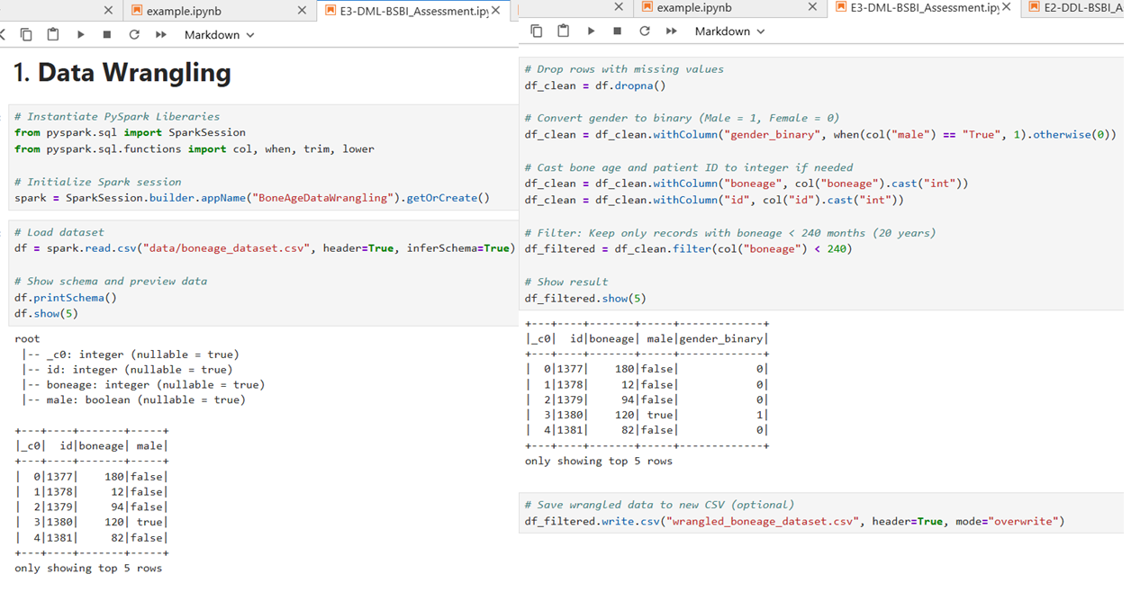

Data Wrangling and Transformations Using Spark
Unfortunately, the SQL queries did not run in Beeline but was successfully implemented using PySpark. I have also display screen shot in Figure 3.2.
Figure 3.2: Shows Data Wrangling activities against the boneAge data / SQL Like Queries for Hive Environment.
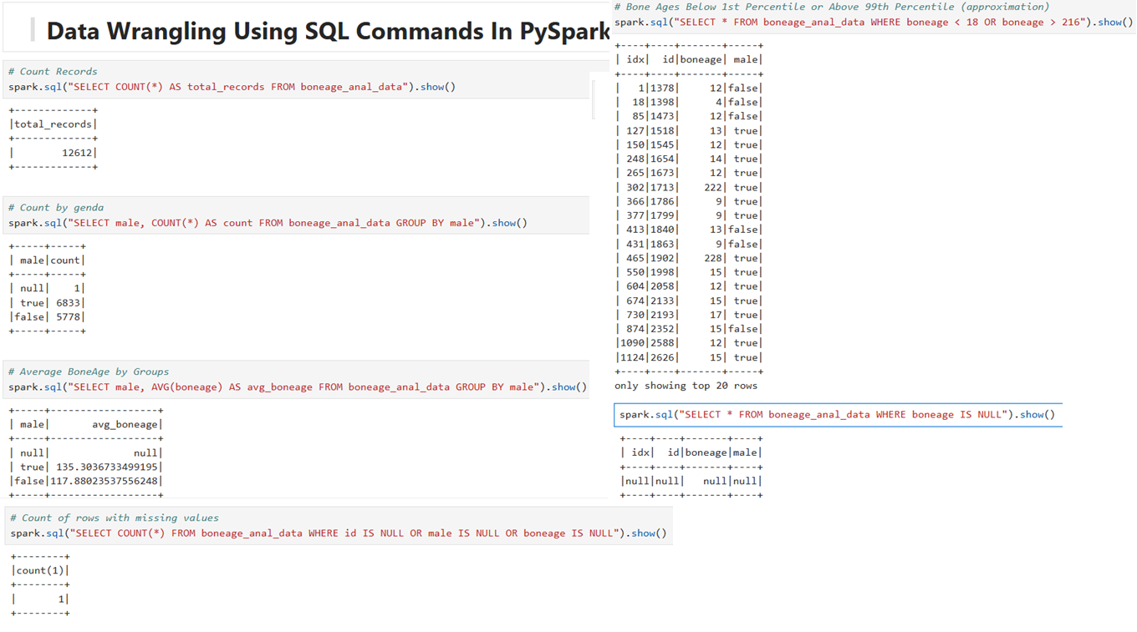
Figure 3.2: Showing error message “User Root is not allowed to impersonate User.
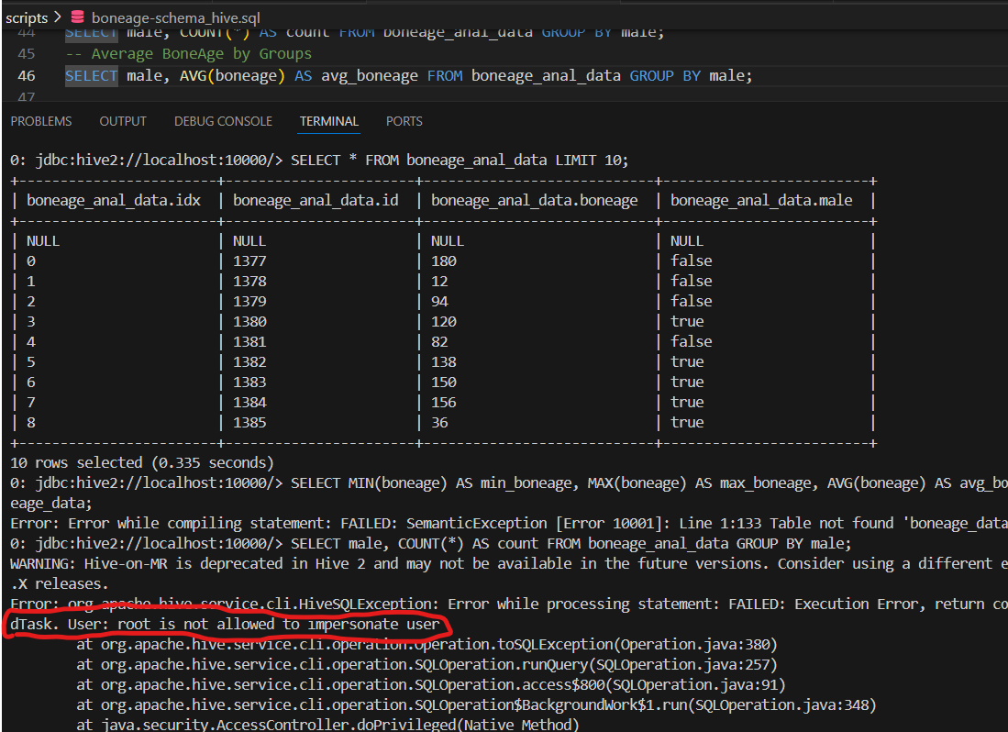

Comparing performance, expressiveness
Rating the overall performance of HiveQL and PySpark, PySpark proven to do better, and is much more suitable for data analysis within this platform. Figure 3.2 display results using the “describe” command version for both applications, and one can see that PySpark shows more statistical details than just columns.
Figure 3.2
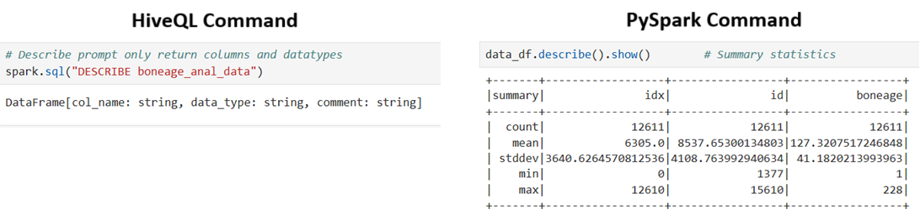

Advanced Analytics and Machine Learning

Machine Learning Algorithm
A convolutional neural network – CNNs was constructed using pandas, numpy and packages from sklearn and tensorflow to predict the age of children based on skeletal development using scanned images of their left hands. See section 4.1.1 below.

CNN Codes
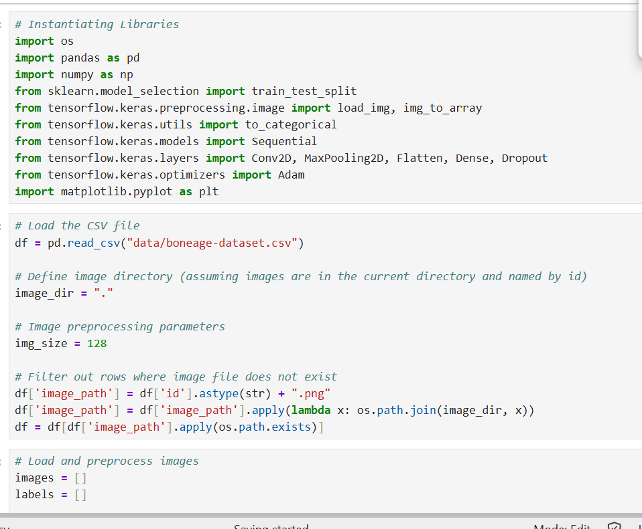
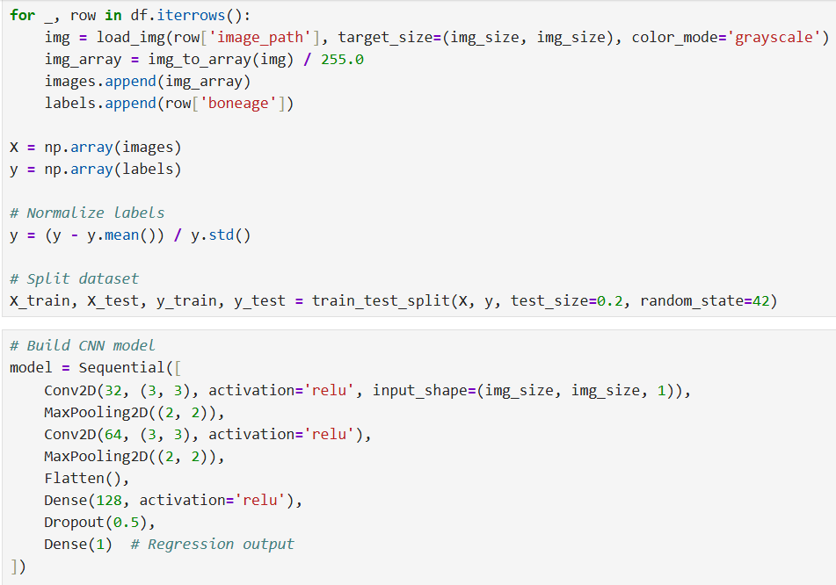
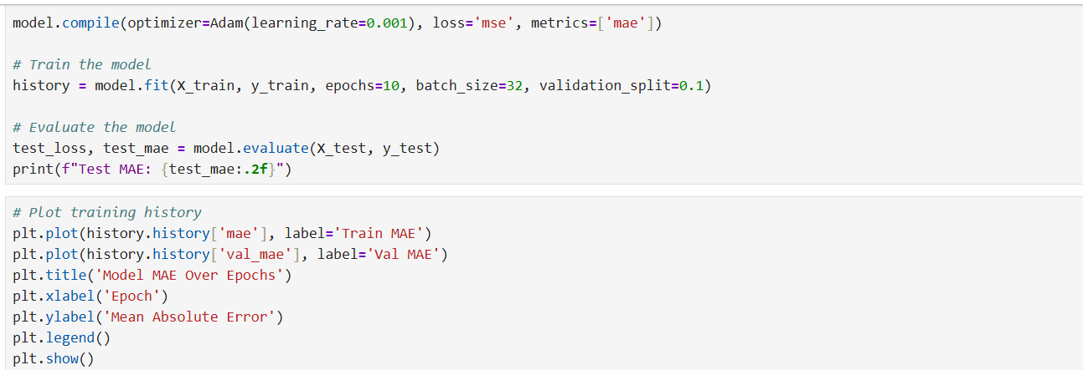

Codes

Reflection and Recommendations

- During the implementation using Beeline CLI, though all commands were executed successfully, the Metadata table displayed null characters. This issue was fixed during the implementation of PySpark, and the reason for that was because the table was not created with delimiter instructing indicating how table will be updated in Hive.
- As a result, on being able to connect to hive using beeline in platform in the Hadoop-Network, the project folder was duplicated into a sub directory called “hive-explore”, due to the limited time.

BIBLIOGRAPHY

​​ How to Calculate Entropy in Decision Tree? - GeeksforGeeks. (n.d.). Retrieved February 9, 2025, from https://www.geeksforgeeks.org/how-to-calculate-entropy-in-decision-tree/
How to Calculate Information Gain in Decision Tree? - GeeksforGeeks. (n.d.). Retrieved February 9, 2025, from https://www.geeksforgeeks.org/how-to-calculate-information-gain-in-decision-tree/
Breiman, L. (2001). Random Forests. 45, 5–32.
Calculate Cramér’s Coefficient Matrix Using Pandas - GeeksforGeeks. (n.d.). Retrieved February 6, 2025, from https://www.geeksforgeeks.org/calculate-cramer-s-coefficient-matrix-using-pandas/
Kluyver, T., Ragan-Kelley, B., & et al. (2016). Jupyter Notebooks – a publishing format for reproducible computational workflows. Positioning and Power in Academic Publishing:
Matplotlib — Visualization with Python. (n.d.). Retrieved February 9, 2025, from https://matplotlib.org/
Mushroom - UCI Machine Learning Repository. (n.d.). Retrieved February 9, 2025, from https://archive.ics.uci.edu/dataset/73/mushroom
Prediction — xgboost 2.1.3 documentation. (n.d.). Retrieved February 9, 2025, from https://xgboost.readthedocs.io/en/stable/prediction.html
scikit-learn: machine learning in Python — scikit-learn 1.6.1 documentation. (n.d.). Retrieved February 9, 2025, from https://scikit-learn.org/stable/
Waskom, M. (2021). seaborn: statistical data visualization. Journal of Open-Source Software, 6(60), 3021. https://doi.org/10.21105/JOSS.03021

​ ​

APPENDIX

Project Repository
Yusufu Repository: https://github.com/ysavage/hadoop-hive-pyspark-docker

Project Repository
- GitHub Repository: https://www.kaggle.com/datasets/kmader/rsna-bone-age

Link to Case Study Data Set
- Healthcare Dataset: https://www.kaggle.com/datasets/kmader/rsna-bone-age

